Complex Rectilinear Shapes
# Source: AI Source: Provided by: [Data Path: Persons Table -> ID Column: 1, Name_En Column: Motasem Essam] -> From: [ChatGPT] on [7/25/2026]
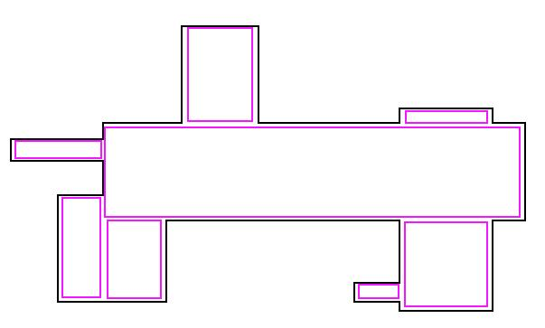
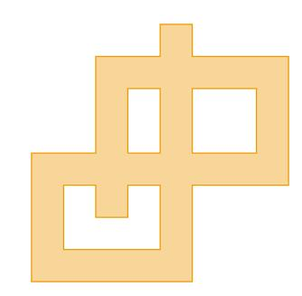
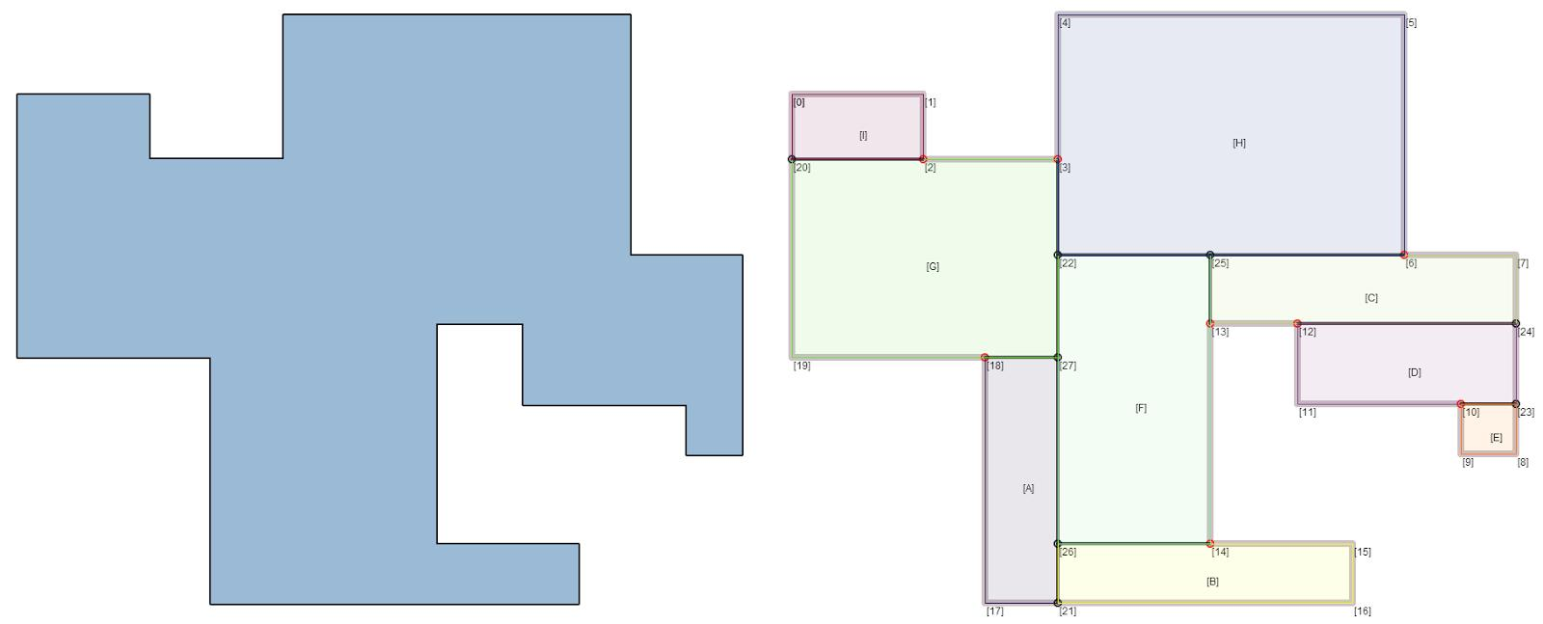
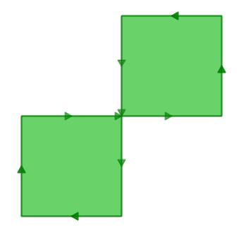

Definition
# Source: AI Source: Provided by: [Data Path: Persons Table -> ID Column: 1, Name_En Column: Motasem Essam] -> From: [ChatGPT] on [7/25/2026]
A Complex Rectilinear Shape is a rectilinear shape with a complicated boundary structure, such as self-intersections, multiple crossings, overlapping segments, or multiple connected components.
A rectilinear shape has a boundary composed entirely of straight horizontal and vertical line segments.
Thus:
$$\boxed{\text{Complex Rectilinear Shape}=\text{Rectilinear Shape with a Complex Boundary Structure}}$$
When the complexity specifically results from the boundary crossing itself, the more precise mathematical term is:
$$\boxed{\text{Self-Intersecting Rectilinear Polygon}}$$

Fundamental Concept
# Source: AI Source: Provided by: [Data Path: Persons Table -> ID Column: 1, Name_En Column: Motasem Essam] -> From: [ChatGPT] on [7/25/2026]
A simple rectilinear shape has a single boundary that does not cross itself.
A complex rectilinear shape may have a more complicated arrangement of its horizontal and vertical segments.
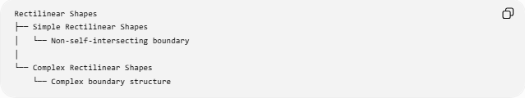
Rectilinear Shapes
├── Simple Rectilinear Shapes
│ └── Non-self-intersecting boundary
│
└── Complex Rectilinear Shapes
└── Complex boundary structure
The distinction is primarily about the structure of the boundary, not merely its appearance.

Main Characteristics
# Source: AI Source: Provided by: [Data Path: Persons Table -> ID Column: 1, Name_En Column: Motasem Essam] -> From: [ChatGPT] on [7/25/2026]
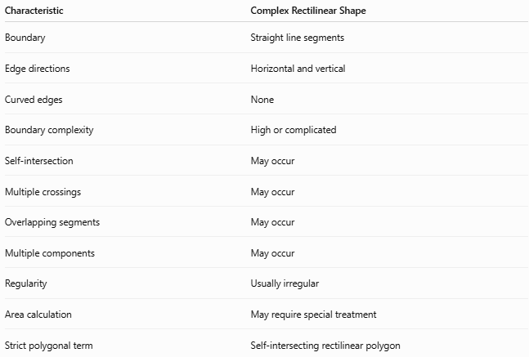
Characteristic | Complex Rectilinear Shape
Boundary | Straight line segments
Edge directions | Horizontal and vertical
Curved edges | None
Boundary complexity | High or complicated
Self-intersection | May occur
Multiple crossings | May occur
Overlapping segments | May occur
Multiple components | May occur
Regularity | Usually irregular
Area calculation | May require special treatment
Strict polygonal term | Self-intersecting rectilinear polygon

Main Types
# Source: AI Source: Provided by: [Data Path: Persons Table -> ID Column: 1, Name_En Column: Motasem Essam] -> From: [ChatGPT] on [7/25/2026]
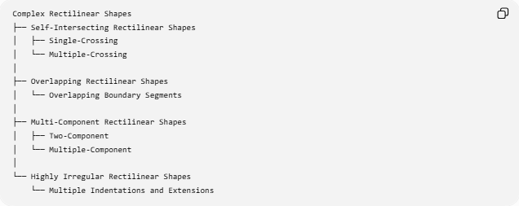
Complex Rectilinear Shapes
├── Self-Intersecting Rectilinear Shapes
│ ├── Single-Crossing
│ └── Multiple-Crossing
│
├── Overlapping Rectilinear Shapes
│ └── Overlapping Boundary Segments
│
├── Multi-Component Rectilinear Shapes
│ ├── Two-Component
│ └── Multiple-Component
│
└── Highly Irregular Rectilinear Shapes
└── Multiple Indentations and Extensions

Self-Intersecting Rectilinear Shapes
# Source: AI Source: Provided by: [Data Path: Persons Table -> ID Column: 1, Name_En Column: Motasem Essam] -> From: [ChatGPT] on [7/25/2026]
A Self-Intersecting Rectilinear Shape has horizontal and vertical boundary segments that cross one another at points that are not ordinary consecutive vertices.
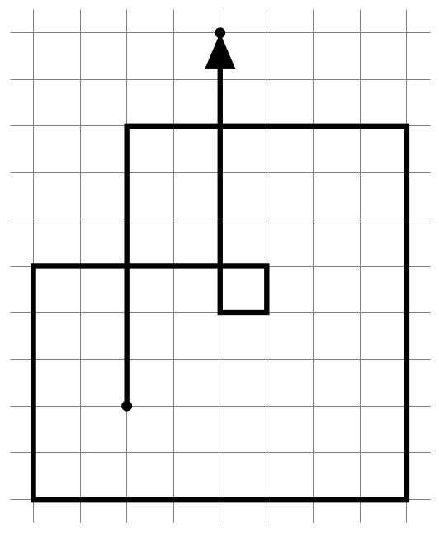
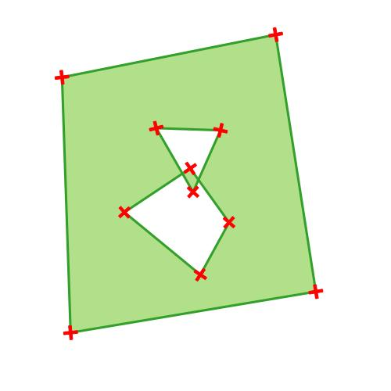
A self-intersection means:
$$\boxed{\text{Two nonadjacent boundary segments cross}}$$
Therefore, the boundary is not simple.

Single-Crossing Rectilinear Shapes
# Source: AI Source: Provided by: [Data Path: Persons Table -> ID Column: 1, Name_En Column: Motasem Essam] -> From: [ChatGPT] on [7/25/2026]
A complex rectilinear boundary may contain one principal self-intersection.
Conceptually:
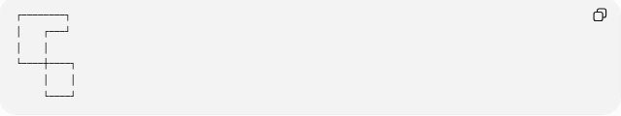
┌────────┐
│ ┌───┘
│ │
└────┼────┐
│ │
└────┘
The crossing point creates a more complicated boundary structure than a simple rectilinear polygon.

Multiple-Crossing Rectilinear Shapes
# Source: AI Source: Provided by: [Data Path: Persons Table -> ID Column: 1, Name_En Column: Motasem Essam] -> From: [ChatGPT] on [7/25/2026]
Some rectilinear boundaries can contain several crossing points.
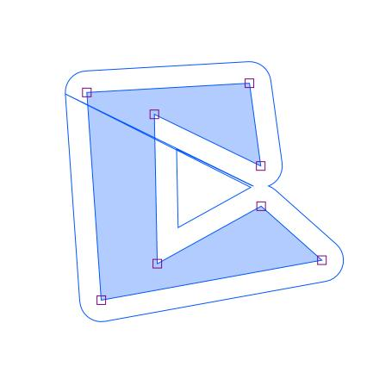
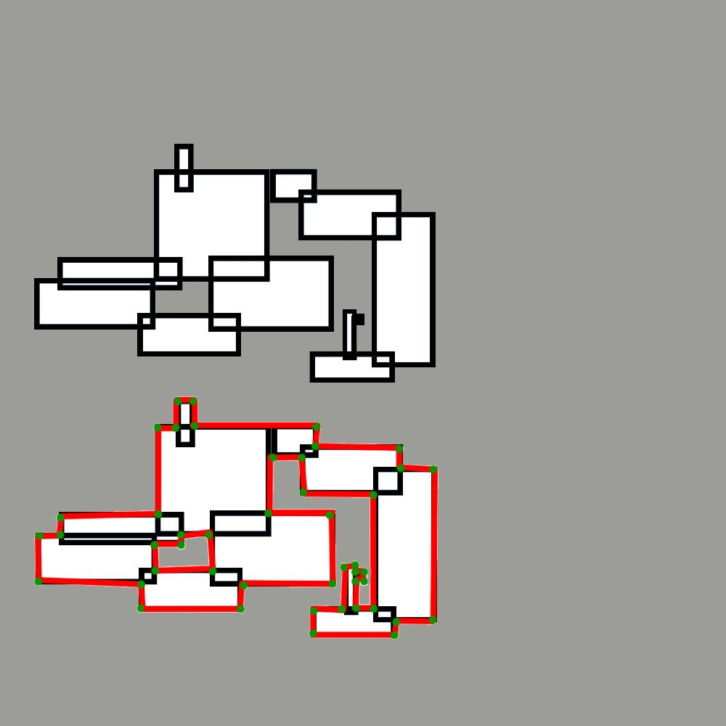
These shapes can have:
- multiple intersection points
- several enclosed regions
- complicated boundary paths
- ambiguous interior regions

Overlapping Rectilinear Shapes
# Source: AI Source: Provided by: [Data Path: Persons Table -> ID Column: 1, Name_En Column: Motasem Essam] -> From: [ChatGPT] on [7/25/2026]
An Overlapping Rectilinear Shape or arrangement may contain boundary segments that partially occupy the same line.
For example:
──────────────
──────────────
The common portion is an overlapping segment, rather than merely a single intersection point.
Therefore:
$$\boxed{\text{Point Intersection}≠\text{Segment Overlap}}$$

Multi-Component Rectilinear Shapes
# Source: AI Source: Provided by: [Data Path: Persons Table -> ID Column: 1, Name_En Column: Motasem Essam] -> From: [ChatGPT] on [7/25/2026]
A complex rectilinear arrangement can contain more than one disconnected component.
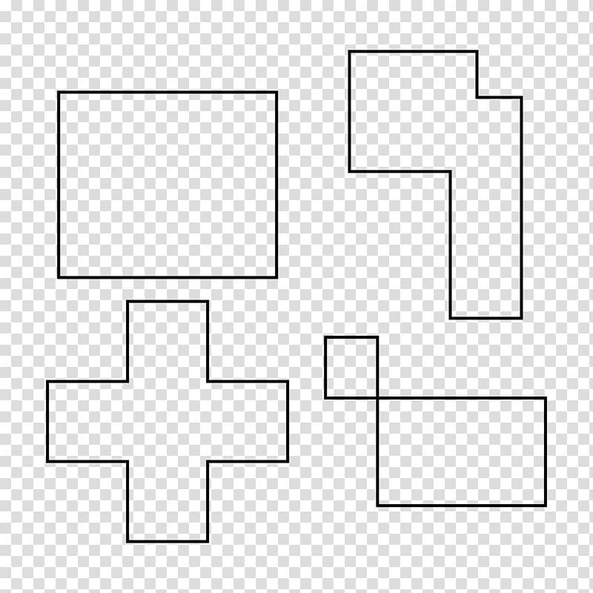
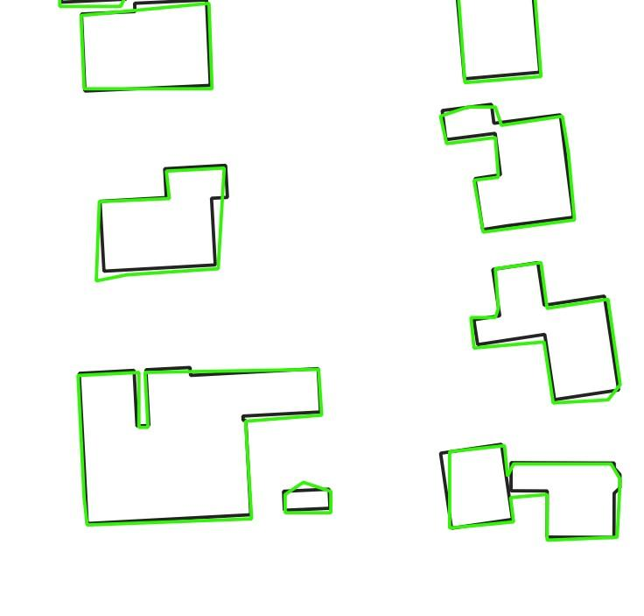
For example:
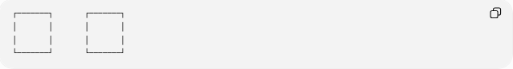
┌───────┐ ┌───────┐
│ │ │ │
│ │ │ │
└───────┘ └───────┘
There are two separate rectilinear regions.
Strictly speaking, this is better described as a set or collection of rectilinear regions, rather than one polygon.

Interior Angles
# Source: AI Source: Provided by: [Data Path: Persons Table -> ID Column: 1, Name_En Column: Motasem Essam] -> From: [ChatGPT] on [7/25/2026]
For an ordinary vertex of a rectilinear polygon, the interior angle is generally:
$${90}^{∘}$$
or:
$${270}^{∘}$$
However, at a self-intersection, the ordinary concept of a single polygon interior angle can become ambiguous.
Therefore, the simple-polygon formula:
$$\boxed{S=\left(n-2\right){180}^{∘}}$$
should not automatically be applied to a self-intersecting rectilinear polygon.

Area
# Source: AI Source: Provided by: [Data Path: Persons Table -> ID Column: 1, Name_En Column: Motasem Essam] -> From: [ChatGPT] on [7/25/2026]
For a simple rectilinear shape, area is usually straightforward.
For example:
$$A=A_{1}+A_{2}+⋯+A_{n}$$
or:
$$A=A_{\text{outer}}-A_{\text{removed}}$$
For a complex or self-intersecting shape, the area may require:
- decomposition into separate regions
- calculation of each enclosed region
- subtraction of overlapping areas
- or a defined signed-area convention
Therefore:
$$\boxed{\text{Complex boundary}→\text{More careful area interpretation}}$$

Perimeter
# Source: AI Source: Provided by: [Data Path: Persons Table -> ID Column: 1, Name_En Column: Motasem Essam] -> From: [ChatGPT] on [7/25/2026]
For a clearly defined collection of boundary segments:
$$\boxed{P=l_{1}+l_{2}+⋯+l_{n}}$$
However, when segments overlap or cross, it is important to specify what is being measured:
- total path length
- outer boundary length
- distinct boundary length
- perimeter of individual enclosed regions

Complex vs. Simple Rectilinear Shapes
# Source: AI Source: Provided by: [Data Path: Persons Table -> ID Column: 1, Name_En Column: Motasem Essam] -> From: [ChatGPT] on [7/25/2026]
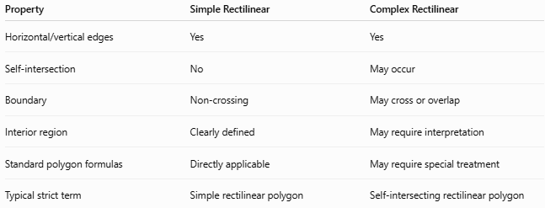
Property | Simple Rectilinear | Complex Rectilinear
Horizontal/vertical edges | Yes | Yes
Self-intersection | No | May occur
Boundary | Non-crossing | May cross or overlap
Interior region | Clearly defined | May require interpretation
Standard polygon formulas | Directly applicable | May require special treatment
Typical strict term | Simple rectilinear polygon | Self-intersecting rectilinear polygon

Complex vs. Concave Rectilinear Shapes
# Source: AI Source: Provided by: [Data Path: Persons Table -> ID Column: 1, Name_En Column: Motasem Essam] -> From: [ChatGPT] on [7/25/2026]
These are not the same classification.
Concave Rectilinear Shape
Has an inward indentation:
$$\boxed{\text{At least one }{270}^{∘}\text{ reflex angle}}$$
Example:
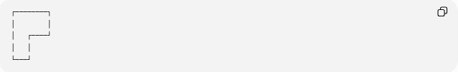
┌────────┐
│ │
│ ┌────┘
│ │
└───┘
It can still be simple.
Complex Rectilinear Shape
Has a more complicated boundary structure, potentially including self-intersections.
Therefore:
$$\boxed{\text{Concave}≠\text{Complex}}$$
An L-shape is normally:
$$\boxed{\text{Simple + Concave + Rectilinear}}$$
A self-intersecting rectilinear polygon is:
$$\boxed{\text{Complex + Self-Intersecting + Rectilinear}}$$

Complex vs. Irregular Rectilinear Shapes
# Source: AI Source: Provided by: [Data Path: Persons Table -> ID Column: 1, Name_En Column: Motasem Essam] -> From: [ChatGPT] on [7/25/2026]
Irregular and complex describe different properties.
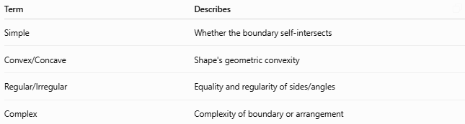
Term | Describes
Simple | Whether the boundary self-intersects
Convex/Concave | Shape's geometric convexity
Regular/Irregular | Equality and regularity of sides/angles
Complex | Complexity of boundary or arrangement
Thus, an ordinary non-square rectangle can be:
$$\boxed{\text{Simple + Convex + Irregular + Rectilinear}}$$
while a self-intersecting shape can be:
$$\boxed{\text{Complex + Irregular + Rectilinear}}$$

Mathematical Classification Tree
# Source: AI Source: Provided by: [Data Path: Persons Table -> ID Column: 1, Name_En Column: Motasem Essam] -> From: [ChatGPT] on [7/25/2026]
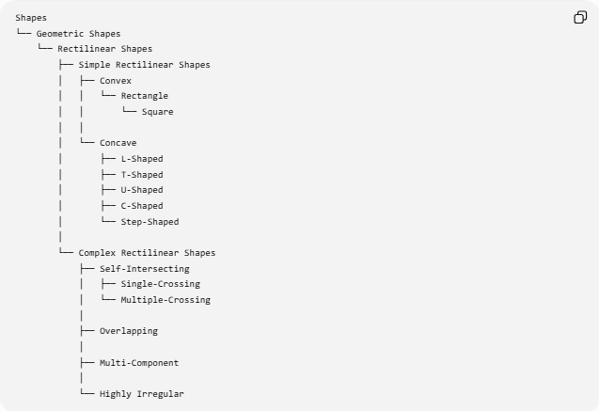
Shapes
└── Geometric Shapes
└── Rectilinear Shapes
├── Simple Rectilinear Shapes
│ ├── Convex
│ │ └── Rectangle
│ │ └── Square
│ │
│ └── Concave
│ ├── L-Shaped
│ ├── T-Shaped
│ ├── U-Shaped
│ ├── C-Shaped
│ └── Step-Shaped
│
└── Complex Rectilinear Shapes
├── Self-Intersecting
│ ├── Single-Crossing
│ └── Multiple-Crossing
│
├── Overlapping
│
├── Multi-Component
│
└── Highly Irregular

Important Terminology
# Source: AI Source: Provided by: [Data Path: Persons Table -> ID Column: 1, Name_En Column: Motasem Essam] -> From: [ChatGPT] on [7/25/2026]
The phrase Complex Rectilinear Shape is useful as a broad descriptive category, but it is not a universally standardized polygon class.
For mathematical precision:
If the boundary crosses itself:
$$\boxed{\text{Self-Intersecting Rectilinear Polygon}}$$
If the boundary does not cross itself but has indentations:
$$\boxed{\text{Concave Simple Rectilinear Polygon}}$$
If there are several separate regions:
$$\boxed{\text{Multi-Component Rectilinear Region}}$$
This distinction keeps the classification mathematically precise.

Key Points
# Source: AI Source: Provided by: [Data Path: Persons Table -> ID Column: 1, Name_En Column: Motasem Essam] -> From: [ChatGPT] on [7/25/2026]
- A Complex Rectilinear Shape has a complicated arrangement of horizontal and vertical segments.
- It may contain self-intersections, multiple crossings, overlapping segments, or multiple components.
- A self-intersecting rectilinear polygon is not a simple polygon.
- Complex and concave are not synonyms.
- Complex and irregular are also not synonyms.
- The standard simple-polygon interior-angle formula should not be applied blindly to self-intersecting boundaries.
- Area and perimeter may require a clearly defined interpretation.
- Self-Intersecting Rectilinear Polygon is the preferred precise term when boundary crossings are the defining feature.

Conclusion
# Source: AI Source: Provided by: [Data Path: Persons Table -> ID Column: 1, Name_En Column: Motasem Essam] -> From: [ChatGPT] on [7/25/2026]
A Complex Rectilinear Shape is a rectilinear shape with a boundary or arrangement that is more complicated than a simple rectilinear polygon. Its complexity may result from self-intersections, multiple crossings, overlapping segments, or multiple disconnected components.
$$\boxed{\text{Complex Rectilinear Shape}→\text{Complex Horizontal/Vertical Boundary Structure}}$$
When self-intersection is specifically intended:
$$\boxed{\text{Complex Rectilinear Shape}→\text{Self-Intersecting Rectilinear Polygon}}$$

